

SIMATS ENGINEERING

Saveetha Institute of Medical and Technical Sciences
Chennai- 602105

Student Name: M. Abinesh Reg. No.:192465050
Course Code: DSA-0135 Slot: C – DSA-0135
Course Name: Object Oriented Programming for Real Time Applications
Course Faculty: Dr. Smitha , Dr. Sararu.
Project Title:
CYBERSENTINEL : Realtime XDR Response System
Module Photographs:
Module Photo | Individual student contribution module work in the project | Presentation Image
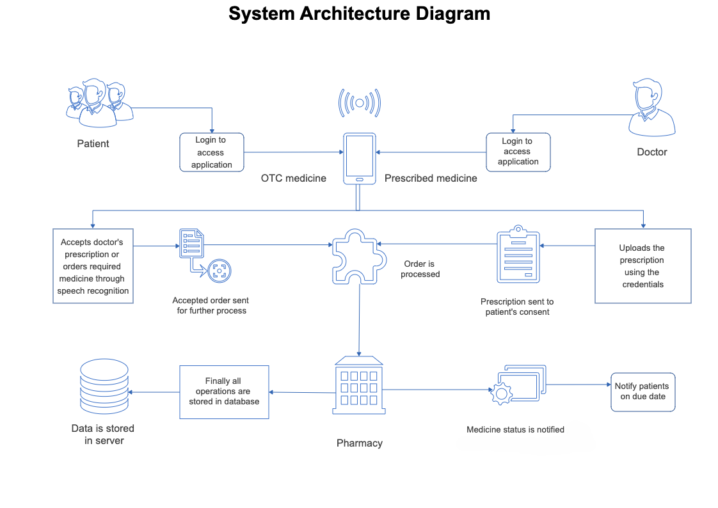 | 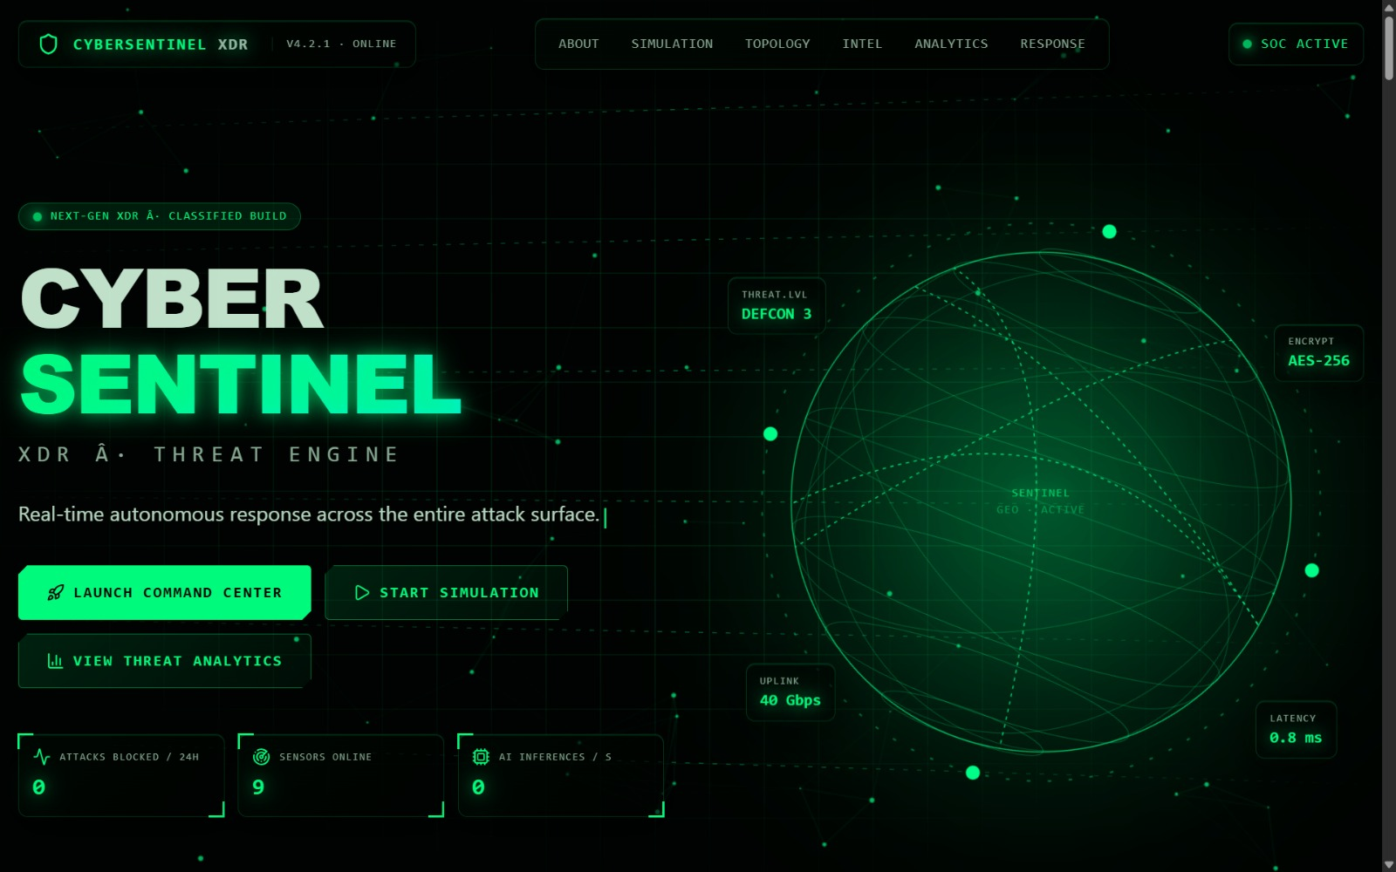 | 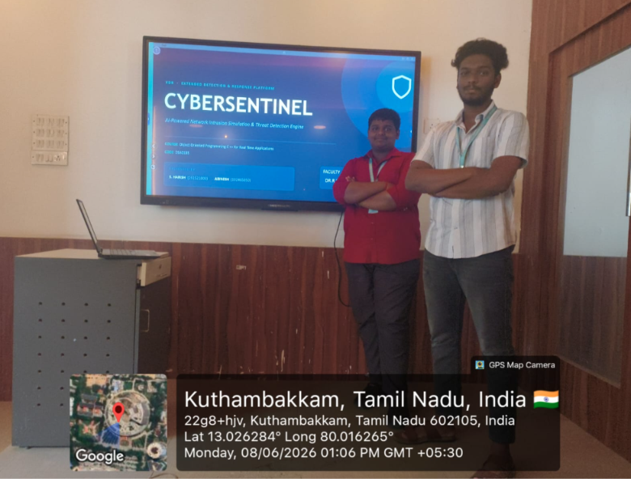
Project Description:
This project presents CyberSentinel (Cyber Sentinel Engine): An AI-driven, multi-engine threat detection platform designed to modernize and streamline intrusion-response workflows across diverse detection layers—namely Signatures, Anomalies, and Correlation. The platform leverages core operating system principles such as process isolation, secure multi-user authentication, inter-process communication, and resource scheduling to ensure secure, scalable, and efficient detection solutions. Each detector module operates as an isolated process, accessing only its authorized flow data, with alert and incident logs managed via secure file system abstraction.
Real-time alerts, escalations, and notifications are built upon OS-inspired event signalling and concurrency models, minimizing race conditions and maximizing responsiveness. The system's cross-platform, console-based architecture assures maximum accessibility—even in bandwidth or resource-constrained networks—enabled by OS-level abstractions and security controls.

Student Signature Guide Signature

